CSC 210.08 (Fall 2022)
Midterm (10/17/ 9:40-10:40)

First:__________________________ Last: __________________________________

[1-15] 3 points each

1. The expression (int)(76.0292175 * 100) / 100.0 evaluates to _int________.

2. What is the value range of the expressions below; [note: 0 <= Math.random() < 1]
a. (int) Math.random()*10 + 1 9
b. (int) (Math.random()*10) + 1 9

3. When “int x = 2;” statement is already executed, what is the value of the expression below;
c. x / 4 0
d. x / 4.0 0.5

4. List 5 numbers that meet the condition below. (10 points)
((number % 2 == 0) || (number % 3 == 0))
2,3,4,6,8

5. If 'a' - 32 makes 'A', how can you make ‘d’ using ‘D’?

6. Please enter the answers below:
0 % 3 = 0
1 % 3 =1
2 % 3 =2
3 % 3 =0
4 % 3 =1
5 % 3 =2
6 % 3 =0
7 % 3 =1
8 % 3 =2
9 % 3 =0
10 % 3 =1
11 % 3 =2
12 % 3 =0
13 % 3 =1
How many groups all integers are divided in to by using “% 3”?
3

0 % 7 =0
1 % 7 =1
2 % 7 =2
3 % 7 =3
4 % 7 =4
5 % 7 =5
6 % 7 =6
7 % 7 =0
8 % 7 =1
9 % 7 =2
10 % 7 =3
11 % 7 =4
12 % 7 =5
13 % 7 =6
How many groups all integers are divided in to by using “% 7”?
6

7. Write a printout after executing following switch statement.

char ch = 'b';

switch (ch) {
case 'a':
System.out.print(ch);
case 'b':
System.out.print(ch);
case 'c':
System.out.print(ch);
case 'd':
System.out.print(ch);
}
b

8. Which of the following expression results in a value 1?
A. 37 % 6 B. 25 % 5 C. 15 % 4 D. 2 % 1
a

9. If you attempt to add an int, a byte, a long, and a double, the result will be a __________ value.
A. long B. byte C. double D. int
a

10. According to Java naming convention, which of the following names can be variables?
A. class B. totalLength C. TOTAL_LENGTH D. FindArea E. findArea
D, b

11. When a code segment is given below, show the value of variable at each line (after execution). n/a means no specific value assigned yet.

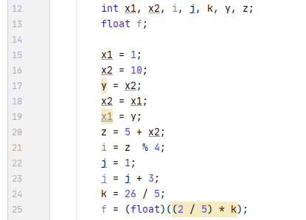

Line no\variables | x1 | x2 | y | z | i | j | k | f
After line 15 exec | 1 | n/a | n/a | n/a | n/a | n/a | n/a | n/a
16 | 1 | 10
17 | 1 | 10 | 10
18 | 1 | 1 | 10
19 | 10 | 1 | 10
20 | 10 | 1 | 10 | 6
21 | 10 | 1 | 10 | 6 | 2
22 | 10 | 1 | 10 | 6 | 2 | 1
23 | 10 | 1 | 10 | 6 | 2 | 4
24 | 10 | 1 | 10 | 6 | 2 | 4 | 5
25 | 10 | 1 | 10 | 6 | 2 | 4 | 5 | 2.0

12. How are (a) and (b) different? Why? What are the outputs of (a) and (b) if there are outputs?

int x = 7;
int y = 8;
int z = 9;

if (x > 9)
if (y > 8)
System.out.println("AAA");
else if (z >= 7)
System.out.println("BBB");
else
System.out.println("CCC");

int x = 7;
int y = 8;
int z = 6;
if (x > 9) {
if (y > 8)
System.out.println("AAA");
}
else if (z >= 7)
System.out.println("BBB");
else
System.out.println("CCC");

- (b)

bbb
bbb

13. Analyze the following code: Which one and which one are equivalent? (10 points)

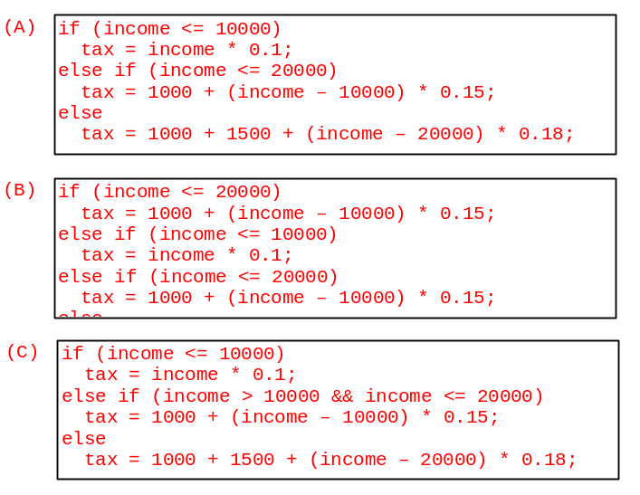
A and c

14. Convert the code below using while. [7 points]

for(int k=1; k<= i; k++)
System.out.print(k + "_");

Int k=1;
While(k<=i){
System.out.print(k+ “_”);
K++;
}

15. Trace the execution path for the following problem. With each line, indicate how the content of variable ‘i’ changes and what is printed out on the console window. [15 points]
Line | ‘i’ | Cout

5: int i = 1;
6:
7: while (i < 20) {
8: if (i < 3)
9: System.out.println(“A”);
10: else // you don’t need to list this line
11: System.out.println(“B”);
12: i = i * 3;
13: if (i > 9)
14: break;
15: else if (i > 6)
16: continue;
17: else System.out.println(“C”);
18:
19: } // you don’t need to list this line
20: System.out.println(“D”);

10a. If you enter input 25, show the printout of the following code: [15 points]
import java.util.Scanner;

public class Test {
public static void main(String[] args) {
Scanner input = new Scanner(System.in);
System.out.print("Enter an integer: ");
int number = input.nextInt();
int i;
boolean isPrime = true;
for (i = 2; i < number && isPrime; i++) {
if (number % i == 0) {
isPrime = false;
}
}

System.out.println("i is " + i);

if (isPrime)
System.out.println(number + " is prime");
else
System.out.println(number + " is not prime");
}
}

I is 6
25 is not prime

10b. If you enter input 13, show the printout of the above code: [15 points]

I is 13
13 is prime

11. Fill in the blank line so that code segments can calculate the below computation [15 points]
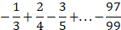
double result=0;

for (int i = 1; i < __1____; i++) {

___________________________________
}

26a What is the output of A, B, and C
public class Increment {
public static void main(String[] args) {
int x = 1;
System.out.println("Before the call, x is " + x);// A
increment(x);
System.out.println("After the call, x is " + x); // B
}
public static void increment(int n) {
n++;
System.out.println("n inside the method is " + n); // C
}
}

1
1
2

4. What will be the output of the following code?
public static void main(String[] args) {
for (int i=0; i<10; i++) {
if (i > 6)
break;
}
System.out.println(i);
}
A. 6
B. 7
C. 10
D. 11
E. Compilation Fails

e

22. Please enter the answers below:
0 % 3 =0
1 % 3 =1
2 % 3 =2
3 % 3 =0
4 % 3 =1
5 % 3 =2
6 % 3 =0
7 % 3 =1
8 % 3 =2
9 % 3 =0
10 % 3 =1
11 % 3 =2
12 % 3 =0
13 % 3 =1
How many groups all integers are divided in to by using “% 3”?
3

0 % 7 =0
1 % 7 =1
2 % 7 =2
3 % 7 =3
4 % 7 =4
5 % 7 =5
6 % 7 =6
7 % 7 =0
8 % 7 =1
9 % 7 =2
10 % 7 =3
11 % 7 =4
12 % 7 =5
13 % 7 =6
How many groups all integers are divided in to by using “% 7”?
7

